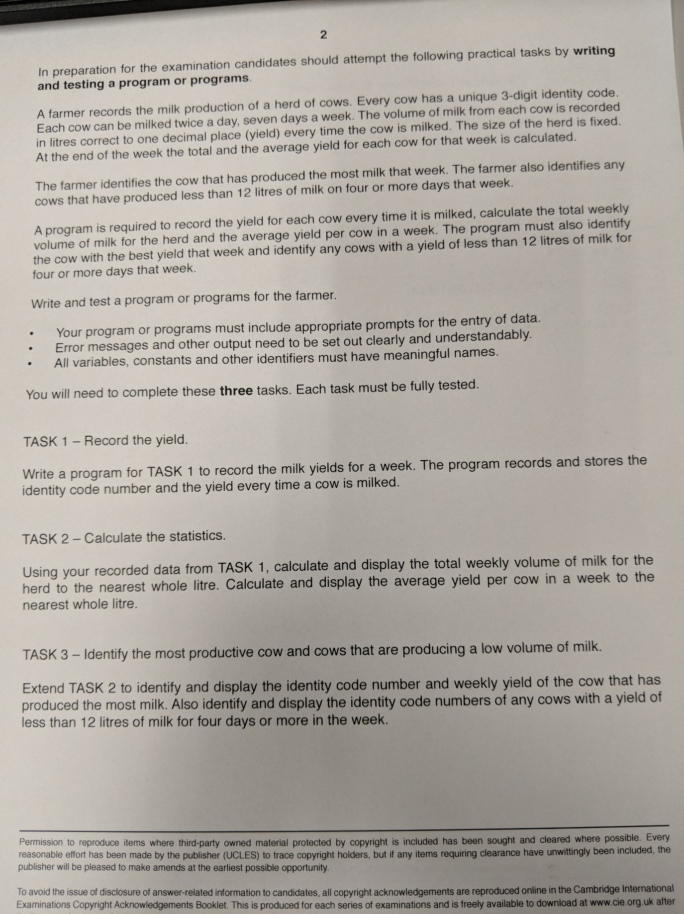

TASK 4 – Yearly Data

The system should allow the farmer to record the data for a given cow over the year. After each week the farmer should store the total for each cow in an array of “year data”. The weekly records and data should then be reset ready for the subsequent week.